4.2Class Diagram
This section presents the Class Diagram of the Lost and Found Board system, which defines the main system entities, their attributes, and the relationships between them, providing a clear structural overview of the system design. As shown in Figure 4.2, this diagram serves as the foundation for implementing the system’s core functionalities.

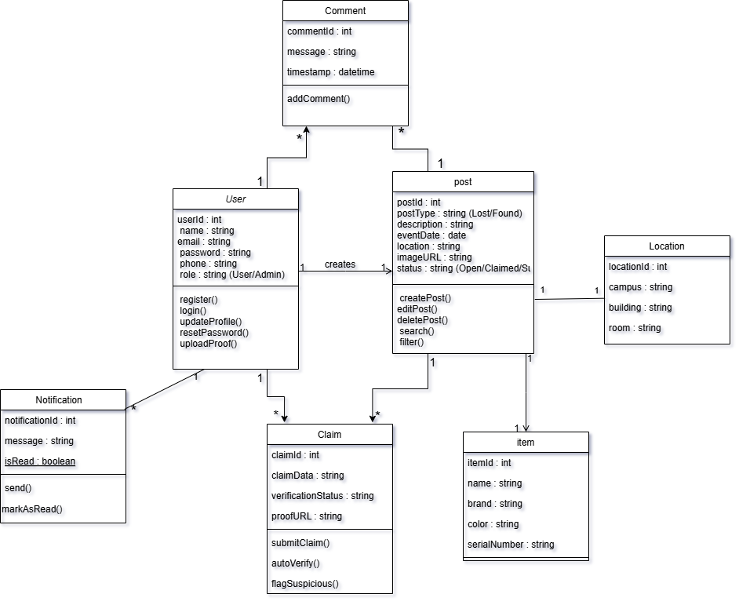
Figure4.2: Class Diagram of the Lost and Found Board System

